Solutions：
NLP input assistance
This project will apply NLP functions to increase information input speed and enhance input accuracy. This is very important for elder users. Care Pathway project and NLP project communicate with each other by agreed API. The integration of two project makes enhance the efficiency of care pathway creation.

The interface of care pathway creator
The main interface can be divided into to part: the left part and the right part.

The left part (Form logic part)
The function of left part is focused on pathway information input. The pathway information could be classified into 2 categories. One is called Conditions. This information is mainly about medical guidelines, with more nature style like questions and answers. Another one is Exit Conditions, which are an combination of conditions picked up from original conditions. It means under these conditions, a specific action would be taken in next step. Different exit conditions lead to different action. The group of conditions involves complicated logic. Using an proper interface to achieve high productivity of exit conditions generation is names as Form Logic in this paper. It is an major problem that should be addressed in this project.

The right part (graph logic part)

The right part is used to visualize pathway information. The pathway data is very different form Object-orientated data. The feature of it is to describe the relationship between information and process or the relationship between process and process. Hence it could be recognized as an Process Modeling Language (PML)-like data. Using an suitable visualization methodology to illustrate all these relationships more legibly is named as graph logic is this paper. It is another crucial problem that should be addressed in this project.

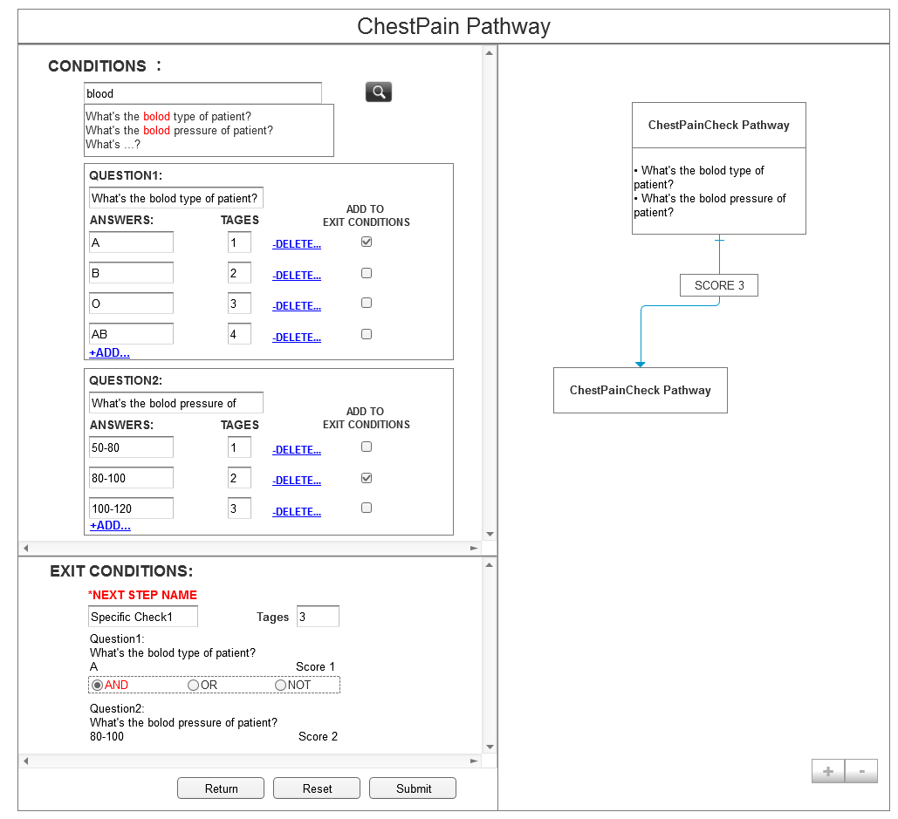
Conditons
Exit Conditons

Left part
Right part

Figure 8. Two parts of interface

Form logic implement:
We have already examined many existing solutions about care pathway logic.One of them is based on Risk Management Process (RMP). The core technique of this approach is to grant each condition a score. The exit criteria is according to the range of the sum of exit conditions’ scores. It is very effective for risk evaluation, but not feasible for build an clear logic between each steps. The optimized interface design have already been proposed in the initial stage of project design, due to the significant drawbacks of RMP, that version have not be adopted.

Form logic based process.
The new solutions is based on the analysis of form logic. There are 2 plans to actualize it.

Conditions-first approach:
1.First, List all conditions, ignoring logic.
3.Define the logic between each condition
4.Create next step
2.Use selector to choose the
Conditions needed.
Conditions First

Figure 9. Conditions First

Firstly, user needs to illustrate all conditions. In this stage, the is no specific relationships between each answers or questions. Then,By using selector, such as check box, user could select the questions and answers needed. At the same time, system would automatically add these conditions into to exit conditions. The relations between those conditions are linked by logic operators, such as and, or and not. Finally, user could create next action by combined exit conditions.
Advantages:
- Very quick for user to illustrate all conditions
- Very quick for user to select conditions.
- Very quick for user to build exit conditions.
- Conditions could be reused any times.
Disadvantages:
The logic operators are so powerful, If they are not used appropriately, the logic could become chaos.

Logic-first approach:
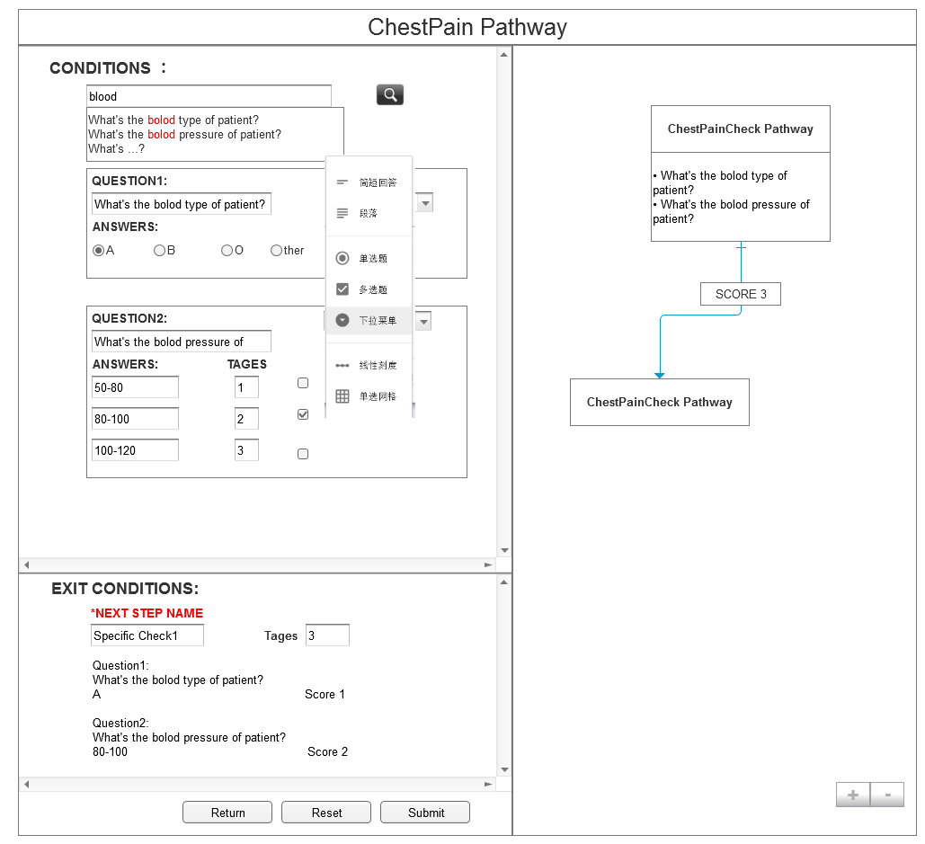
2.Answer the form
3.Generate one exit conditions
4.Create next action
1.Build a form as real one, like Google form

5. Redo step 2, 3, 4
Logic First
First

Figure 10. Logic First

First step, user needs to build the a form. This form is almost the same as a real survey. So the logic between each conditions are established at this time. After the form is finished, user need to fulfill it to generate one exit conditions. The last step is to crate next action.
Advantages:
The form created is very formal.
The whole process is very standardized and formative.
The form can be saved as a record.
The process is very easy to understand.
The logic between each condition is very clear.
Disadvantages:
User fulfill form once, could only generate one exit conditions. So the productivity of these approach is not high.

Graph logic implement:
The pathway is an complicated structure of work-flow graph rather than an traditional chart. To display it more logically, the best approach is to redevelop existing work-flow JS libraries. There are some candidates:
1.GoJS: (The best one )
- It is a feature-rich JavaScript library for implementing custom interactive diagrams and complex visualizations across modern web browsers and platforms.
2.JSPlumb(good at drawing we only need displaying)
- jsPlumb provides a means for a developer to visually connect elements on their web pages.
3. D3JS(highest rating but suitable for char not work-flow)
It is a JavaScript library for manipulating documents based on data.

By carefully evaluating 3 main diagram JS libraries, GoJS is the preferable one to be adopted.It is specialized in work-flow chat illustrating. The design of graphic Care Path way plain is shown bellow:
- An element of Care Path graph is Group.
- A group generally contains 3 parts
- Title/Step name/Action name
- Questions and Answers/Instructions
- Exit conditions.Especially, there could be more than one exit conditions.While if it is an action, there might not be any exit conditions.
- Each exit condition is one connection point to other Groups.
4. The tags could be shown in the line
Title/Step/Action

- Instructions
- Questions
- Answers
Tags
Tags

- Exit condition1
- Exit condition2
- Exit condition3

Tags
Tags

Node

The basic element The connection of elements
Figure 11. Node and connections

Particularly, in order to show information of each element more clearly,
We chose accordion design of each part of node. The layout of whole care path way could be
Horizontal.
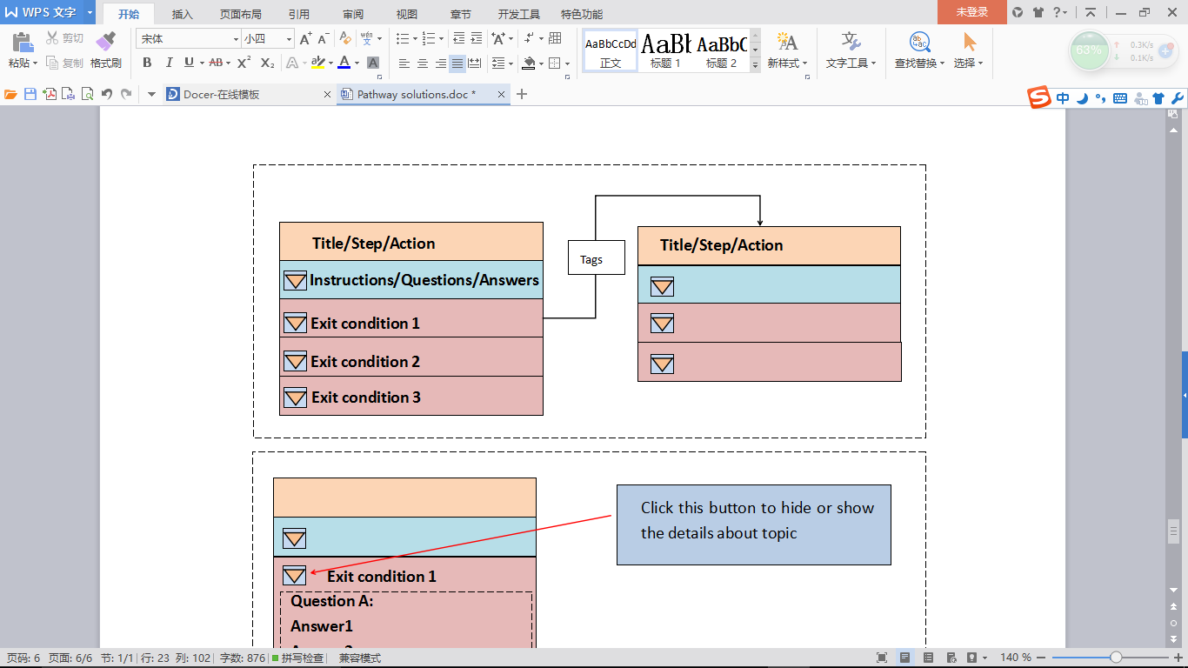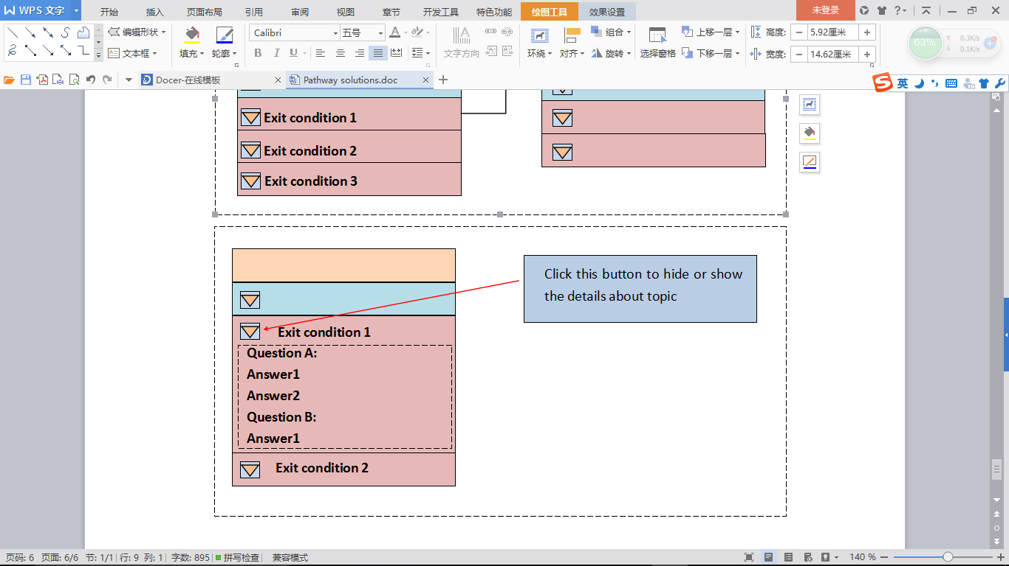
Figure 12. Horizontal connect and accordion

Architecture technology:

We because the many function of this project could be completed in one page. So we adopt SPA Framework and technology for this project.

Ruby on Rials : It is a full stack, Web application framework optimized for sustainable programming productivity, allows writing sound code by favoring convention over configuration.

AngularJS: It is an ideal front-end framework for an application built on top of a RESTful API. Using two way bounding and templates, AngularJS is very suitable for form based applications. The form logic part of this project would be benifit a lot form this.

GoJS: It is very good at implementing graph logic part of this project.

Json: It is widely used for javascript data transformation.

RequireJS: it is used for components loading management.

NodJS: it is a JavaScript runtime built on Chrome engine. It uses an event-driven, non-blocking I/O model that makes it lightweight and efficient

AngularJS

NodeJS

AngularUI
GoJS
RequireJS

Json
Ruby On Rails

Figure 13. The technology structure

The implement of Clinical Pathway Editor

Min Zan a1673755
Yuzhu Wang a1690773

1.Introduction
Different from traditional domain, health care is a kind of intelligence intensive work. It has very high requirements for relevant personnel and strict operation process. Doctors or nurses are required to make some critical decisions to deal with patients’ symptoms during a very short period of time, especially in the ED, is known to cause stress to be accumulated [1]. This is an extremely crucial and complicated process, which means health care providers must accord to professional knowledge, medical evidences and medical guides to ensure their diagnosis and treatment accurate and in time. For novices, sometimes, it is really of great difficulty to take steps to deal with such emergency due to lack of knowledge.

For doctors, they also need some facilities to assist them make decisions when in doubt. In this circumstance, medical guidelines would play an important role in assistance [2]. Novice clinicians may require guidance more frequently and step by step, while experienced doctors tend to have a free hand and need guidance for check when uncertain. Hospitals also have recorded the best practice for treating medical conditions, which is an important complementary for academic guidelines. All of those performances could be abstracted as a medical model in the form of ‘Health Care Pathways’, which is just a tool designed to help general practices manage and refer patients to secondary, tertiary, and community services.

1.1Background

1.1.1 The Definition of Health Care Pathways (HCPs)
There are various definitions of HCPs from different point of view. There is no standard definition for HCPs [3]. It concluded that HCPs are tools that used to manage the patient care and standardize the care processes, based on documenting the hospital’s best practices for each medical condition. It contains management tactics to provide action sequences to achieve decision making goals with optimal methodology. In this sense, it is a distinctive category of workflow with a number of merits [4].
To a certain extent, HCPs is a kinds of workflow, but they have their own features. For example, in traditional Office Automation(OA) workflows, the processes and steps are tending to be fixed. It is very clear that what to do next, and the direction of workflows are basically single way. There are relatively fixed processes and steps, basically a linear process. While the workflows in HCPs are more dynamic and varied. The sequences among present to clinicians, examine, diagnose, treatment will be very disordered and are usually turned to be complicated iterations. Almost each step in four could lead to any other step. The decision factors will vary, under different context. Therefore, from the view of highest level, the HCPs is more likely to be an Incremental model rather than a flow model. It is very hard to be implemented by traditional computer language and data structure. It is more flexible and required to be descripted accurately. This is the core problem need to be solved in HCPs system. Through the analysis of different existing modeling languages, the PML language is chosen as the most suitable one. The obvious advantages of PML is that, apart from the flexible description of following actions, PML adds tight information communication between relative actions. Thus, in addition to the restrictions on the actions, there are also strict restrictions on the resources needed for actions. With the resources- information needed or produced by each action, it is much easier to create the sequences between each action. The action flows and step branches become more clear [5].

1.1.2 Why Health Care Pathways (HCPs)
A great amount of reports indicate that HCPs can play a critical role in health-care supporting process. It is a versioned document of medical guide, and offer users a structured, evidence-based and standardized process improvement methodologies [6].

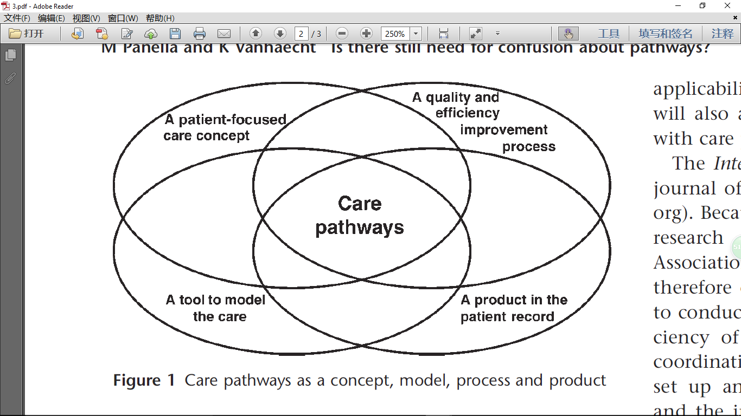
- HCPs could decrease the duration of the production process which reduces waiting time significantly. Especially in Emergency Department, the earlier the diagnosis is established, the sooner treatment can begin. [6]
- HCPs could increase interactions between different departments that are involved in the production. At the same time, evidence-based interaction between patients and doctors could provides a better overview of illness. [6]
- HCPs could also reduce the risk of errors. Every step of HCPs follows medical guidelines or practical experiences, which provides accurate instructions to both novice and experienced doctors. [6]
- HCPs could reduce the cost of the production process. Standardized actions and optimized process ensure maximum usage of equipment and other resources which leads to effective reducing of costs. [6]
- HCPs increases the job satisfaction of employees. Automatic frameworks cut down more inefficient work behaviors which turn down the labor strength of staff. [6]
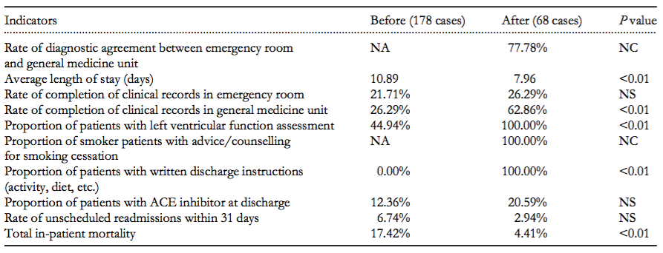
Figure 2： The result of implementing Health Care Pathways for heart failure

According to a research in 2003 [7], the performance of HCPs in practice led to dramatic reductions in health care macro-variation phenomena (length of stay, patient pathways, etc.) and in performance micro-variation (variations in diagnostic and therapeutic prescriptions, protocol implementation, etc.). HCPs was definitely helpful for clinical risk management and cost saving.

1.2 The problems of Health Care Pathways
Despite those profits HCPs has brought to us, the establishment of such a pathway encounters problems.

1.2.1 Accessibility
Although searching HCPs is already available from the internet, it often returns a large list of results, many of them may not HCPs. It is difficult for hospital staff to find what they need. Also, most of the current HCPs is stored in the form PDF or document files with no interactivity. A more interactive way is need to help hospital staff making decisions.

1.2.2 Reflection
To keep updating the latest HCPs is difficult. Medical evidence changes often [8]. 90% of medical guidelines are valid only for 3.6 years and 50% of medical guidelines valid for 5.8 years. At the same time, hospitals could not make changes for their HCPs in accordance with their own medical evidences, which means that HCPs faces a lot of edit, modify, and update problems.

1.3 Project Goal
The goal of this project is to create a pathway editor which provides the link between current clinical pathways and hospital staff as well as transfer the PDF or document files into electronic clinical pathways which can guide hospital staff in a more interactive way, help hospital staff to make accurate decisions and improve their working efficiency. The system should be user friendly image, simple, easy to understand and follow as the main user of the system will be old people with no or less computer experiences. Additionally, care pathways created by the system should can be used in different size and in different devices, such as laptop and mobile phone.
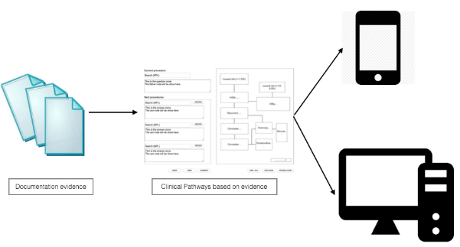
Figure 3

2.Literature Review

2.1 Health Care Pathways Editor

2.1.1 User Interface (UI)
The importance and difficulties of electronic health care pathways (E-HCPs) Editor has been addressed in many researches and reports [9].
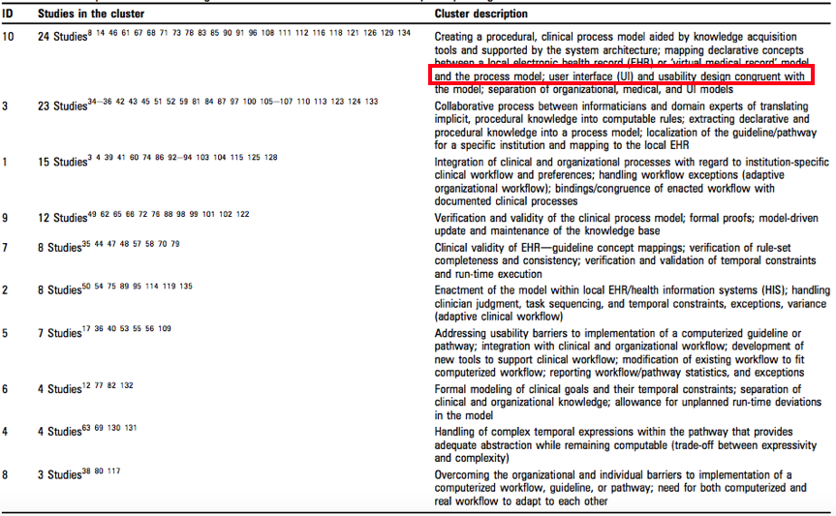
Figure 4：The frequency of UI mentioned in Health Care Pathways

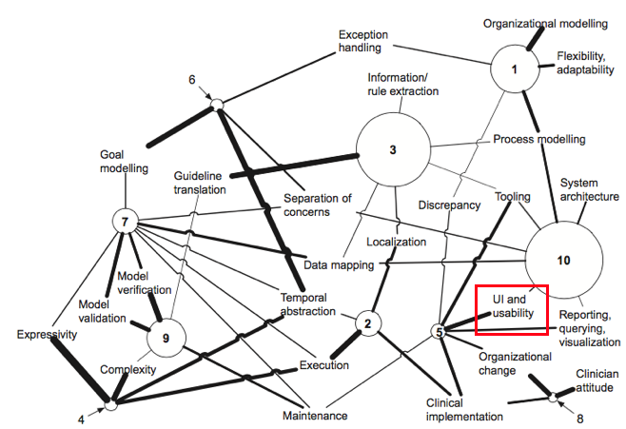
Figure 5：The importance of UI in Health Care Pathways

2.1.2 Problems
To establish a practical and efficient HCPs system is of great difficulties and challenges. Currently, according to the latest research and analysis of ATSC in Royal Hospital Adelaide, HCPs system is encountered a lot of problems [10]:

- Most of the Pathway is stored as PDF documents. Medical staff can not very
easily to find an accurate pathway to comply with.
- The current system does not provide efficient HCPs search and interactive
solutions, so in an emergency, the existing HCPs system lacks sufficient usage and adherence
- The existing establish HCPs is not suitable for elder doctors and professors to
used. The major user of HCPs editor is senior exports. However, these
doctors, professors are tended to be unfamiliar to operate computer. The
current system is not user-friendly to elder users.

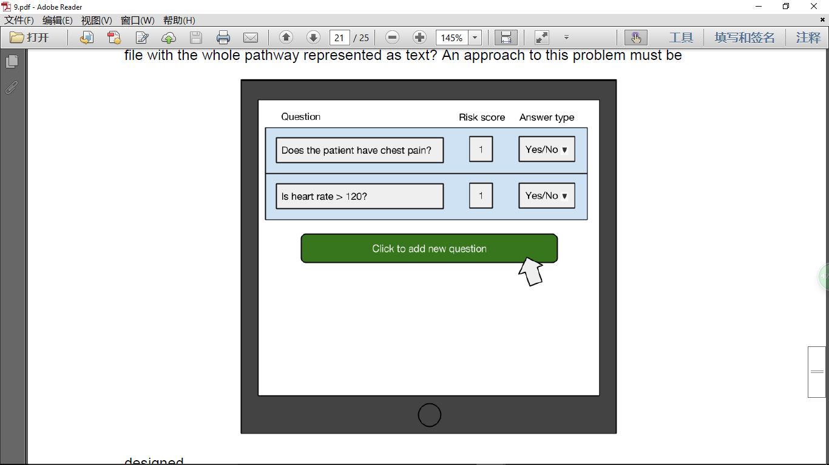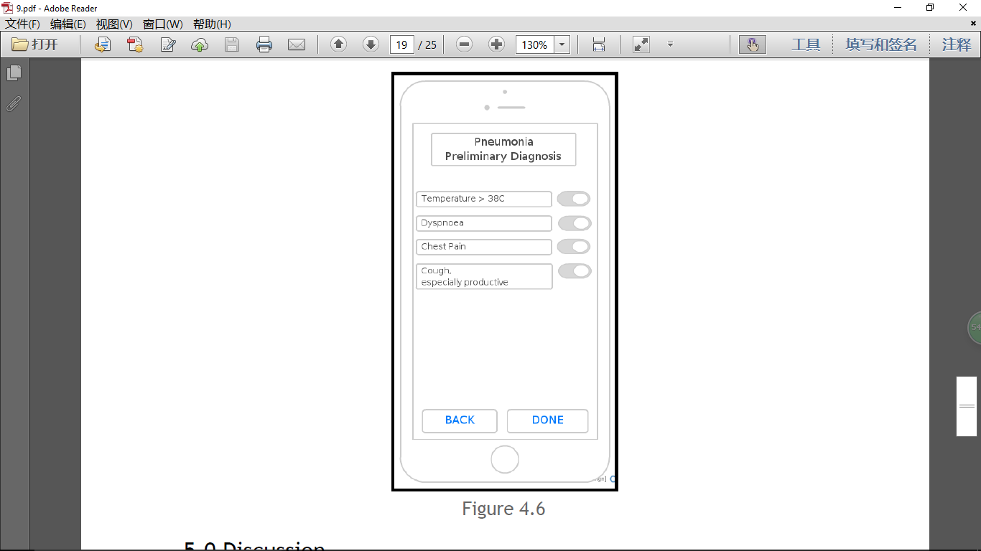
Figure 6：UI prototype of Health Care Pathways

According to the analysis above, the most important problem of current system is
lack of accessibility and adherence. To upgrade HCPs editor is one of the most
significant aim of our work. Our project will be mainly completed the following goals:

- Based on current PML model and data structure, to research and develop a new HCPs create and edit process. To provide a more efficient decision-making PML.
- To update the frameworks of current HCPs editor, implementing the latest
SPA technology. Rewritten HCPs editor.
- Greatly enhance the interaction and user experience of HCPs editor so that
users, especially the elder users, could use it effectively and efficiently.
- The HCPs editor will also integrate with intelligent search, input assistant and
other functions to enhance the HCPs edit.
- The new HCPs editor will also can be deployed on PC, Pad, and other mobile
devices.

2.2 Existing Care Pathways

2.2.1 NICE Pathways
The National Institute for Health and Care Excellence (NICE) used in hospitals throughout the United Kingdom that provides advice and guidance, developing quality and performance standards for public health and social care practitioners to improve national health care. An online tool provides quick and easy access guidance from NICE to help patients and health care staff.
The NICE pathways only provide guidance and advice written as text to doctors. It cannot help the health care staff to make ultimately decision. As illustrated in the figure below, making evidence based medical guidelines has already accessible. Clinical pathways that the accessible required is a system that existing document pathways can be added and updated as well as reflected on the latest information. In addition, the pathways must be accessible in the emergency department and followed with interactive software.

2.2.2 Use PML to create pathways
One solution argued in the literature is that create an editor that can support writing Process Modelling Language (PML). [11] An example below was used to model the Royal Adelaide Hospital’s clinical pathway for pneumonia in PML code. Each step of the pathway is represented by an action. The keyword “provides” means when the stage needs to calculate the risk score, while the keyword “requires” represents that risk score is required to enter into a stage.
Through modelling the structure of the pathway can be correctly modelled, but there are two problems. The first problem is that the patient symptoms are usually complicated that cannot easily be represented. PML does not have keyword for showing a string and numerical value pair (e.g. Does the patient have head pain?). To solve this problem, the script keyword needs to be implemented. The second problem is that using PML to create pathway require care group members can write PML, however, it is impossible for most of the clinicians.
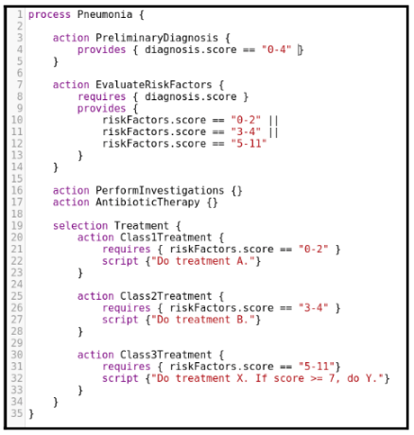
Figure 7

3. Solutions

4 Project Plan
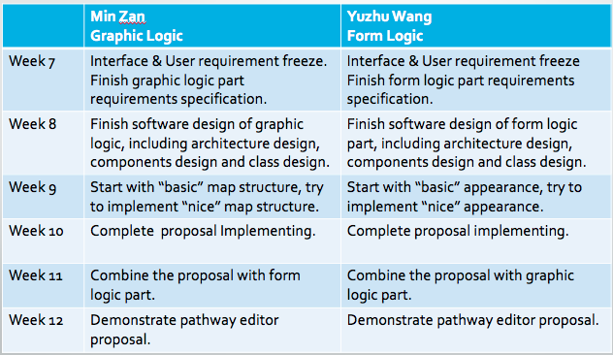

5. Conclusion
We have had a basic understand about the clinical pathway creator system. The system will be mainly used by medical experts to create new clinical pathway or reflect the existing clinical pathways which are in the form of PDF or document files into the clinical pathways system. The system can support clinicians interacting with every stage of the clinical process. The system can also provide digital clinical pathways which the doctor can access to, by using mobile phone and other mobile devices instead of holding a lot of complex document files at the care point when a patient is being treated.
We believe that this approach will be well suited for supporting staff in hospital, especially novices who may need advice and guidance at every stage of process execution. Our initial design of the system has been positive, since our aim is to create a clinical pathway creator which is easy to understand and use. We believe that our approach has potential and plan to do more research to find a better solution and create a prototype system during this semester.

Reference:
[1] Singh, Gurvinder Pal. "Job stress among emergency nursing staff: a preliminary study." Indian journal of psychiatry 55.4 (2013): 407.
[2] Padraig O’Leary, Brunetti L, Noll J,et al.Clinical Pathway Support System.
[3] De Bleser, Leentje, et al. "Defining pathways." Journal of nursing management 14.7 (2006): 553563.
[4] Is there a future for pathways - Five pieces of the puzzle Kris Vanhaecht*§, Massimiliano Panella†§, Ruben Van Zelm‡§ and Walter Sermeus*§
[5] O’Leary P, Noll J and Richardson I.A Resource Flow Approach to Modelling Care Pathways. Springer-Verlag Berlin Heidelberg 2011.P1-P18

[6]The care pathway: concepts and theories: an introduction，Volume 12, 18 September 2012 Publisher: Igitur publishing URL:http://www.ijic.org URN:NBN:NL:UI:10-1-113788 / ijic2012-192 Copyright
[7] Panella M, Marchisio S and Distanislao F. Reducing clinical variations with clinical patheways:do pathways work?.International Journal for Quality in Health Care 2003.15(6)
[8] Shekelle, Paul G., et al. "Validity of the Agency for Healthcare Research and Quality clinical practice guidelines: how quickly do guidelines become outdated?." JAmA 286.12 (2001): 14611467.
[9] Gooch P, Roudsari A. Computerization of workflows, guidelines, and care pathways: a review of implementation challenges for process-oriented health information systems. J Am Med Inform Assoc 2011.18:738-748
[10] Sermeus W, Vanhaecht K, Vleugels A. The Belgian–Dutch clinical pathway network. J Integr Care Pathways 2001;5:10–4: Submitted: 8 October 2011, revised 18 May 2012, accepted 21 June 2012
[11] HSE. Health Service Executive Transformation Programme (2007– 2010), 2007. See http://www.hse.ie/eng/staff/FactFile/HSE_Approach/ Transformation_Programme_2007-2010_/ (last accessed 12 January 2010)

